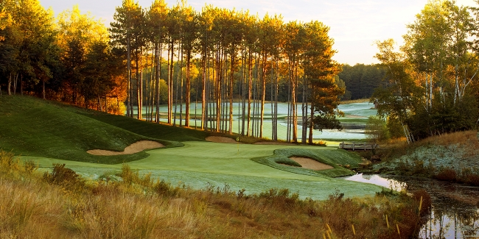
MAY 2019

SUN | MON | TUES | WED | THUR | FRI | SAT
 |  |  | 1 | 2 Men’s League  Buffet | 3 | 4
5 | 6 | 7 | 8 | 9 Men’s League  Snack Night | 10 | 11
12 | 13 | 14 | 15 | 16 Men’s League  Buffet | 17 | 18
19 | 20 | 21 | 22 | 23  Men’s League  Snack Night | 24 | 25
26 | 27 | 28 | 29 | 30 Men’s League  Buffet | 31

2nd INDIVIDUAL STROKE PLAY

9th 2-MAN BEST BALL

16th 4-MAN BEST BALL

23rd 2-MAN SCRAMBLE

30th 4-MAN 4-3-2
JUNE 2019

SUN | MON | TUES | WED | THUR | FRI | SAT
 |  |  |  |  |  | 1
2 | 3 | 4 | 5 | 6  Men’s League  Snack Night | 7 | 8
9 | 10 | 11 | 12 | 13  Men’s League  Buffet | 14 | 15
16 | 17 | 18 | 19 | 20  Men’s League  Snack Night | 21 | 22
23  6-6-6 Tournament | 24 | 25 | 26 | 27  Men’s League  Buffet | 28 | 29
30

6TH INDIVIDUAL STROKE PLAY

13th 2-Man 3-3-3
#1-3 Scramble
#4-6 Best Ball
#7-9 Alternate Shot

20th 4-Man Best Ball
*Due to Event may be
5:45-6:00 Shotgun

23rd 2-Man 6-6-6 Tournament
#1-6 Best Ball
#7-12 Scramble
#13-18 Alternate Shot

27th 4-Man Low Net
(90% of total team Handicap)

*Due to Event may be
5:45-6:00 Shotgun

JULY 2019

SUN | MON | TUES | WED | THUR | FRI | SAT
 | 1 | 2 | 3 | 4  Happy 4th of July | 5 | 6
7 | 8 | 9 | 10 | 11  Blue Fescue | 12  Blue Fescue | 13  Blue Fescue
14 | 15 | 16 | 17 | 18  Men’s League  Snack Night | 19 | 20
21 | 22 | 23 | 24 | 25  Men’s League  Buffet | 26 | 27
28  4-Man Best Ball | 29 | 30 | 31

4th NO MEN’S LEAGUE

11th NO MEN’S LEAGUE

18TH 4-Man Best Ball
*Due to Event may be
5:45-6:00 Shotgun

25th 2-Man Pinehurst

*Both Golfers on the team hit drives
*Partners hit other partners 2nd shot
*After their second shots, they compare the results. Which golf ball is in the best position? They select that ball and pick up the other
*From the third stroke on, they play alternate shot until the ball is holed

28th 4-Man Best Ball Tournament

AUGUST 2019

SUN | MON | TUES | WED | THUR | FRI | SAT
 |  |  |  | 1  Men’s League  Snack | 2 | 3  Club Championship
4  Club Championship | 5 | 6 | 7 | 8  Men’s League  Buffet Night | 9 | 10
11  Last Man Standing | 12 | 13 | 14 | 15  Men’s League  Snack | 16 | 17
18 | 19 | 20 | 21 | 22  Men’s League  Buffet Night | 23 | 24
25 | 26 | 27 | 28 | 29  Men’s League  Snack Night | 30 | 31

1st Individual Stroke Play

3rd Club Championship 7AM start
4th Club Championship 7AM start

8th 2-Man Vegas
*Lowest number 1st
*Player one shoots a 7 and player two
shoots a 4, their score is a 47

11th Last Man Standing Event

15th 4-Man 4-3-2

22nd 2-Man 6-6-6

29th 4-Man Scramble

SEPTEMBER 2019

SUN | MON | TUES | WED | THUR | FRI | SAT
1 | 2 | 3 | 4 | 5  Men’s League  Snack Night | 6 | 7
8 | 9 | 10 | 11 | 12  Men’s League  Buffet Night | 13 | 14
15  King of the Burne | 16 | 17 | 18 | 19 | 20 | 21
22 | 23 | 24 | 25 | 26 | 27 | 28
29 | 30

5th Individual Stroke Play

12th 2-Man Best Ball

15th King of the Burne

